**Project Documentation**

1. **Requirement Gathering**
2. **Analysis**
3. **Define Total Number of User**

**Visiter                         Website**

**Customer               Website**

**Administration          Administration panel**

**Employee                  Employee panel**

1. **Define user task**

**Visiter**

**Categories view Category_table**

**Product  view Product_table**

**Contact us Contact_table**

**Customer**

**Signup             Customer_table**

**Login                                       Customer_table**

**Categories view                                             Category_table**

**Product  view           Product_table**

**Search item                                                    Customber_table**

**Add to cart                        Cart_table**

**Add to wishlist                                               Wishlist_table**

**Place order         Order_table**

**Payment         Payment_table**

**Manage order [cancel /delete/view /edit item] Order_table**

**Track Order                                                  Order_table**

**Verify OTP for Delivery Customer_table**

**Customer help Customer_table**

**Contact us   Contact_table**

**Logout Customer_table**

**Administration**

**Login               Admin_table**

**Manage Categories          Category_table**

**Manage Products               Product_table**

**Manage Customer         Customer_table**

**View cart report           Cart_table**

**View order report                 Order_table**

**View payment report Payment_table**

**View contact report Contact_table**

**Manage Employee[add - upd - del] Employee_table**

**Logout Admin_table**

Employee

**Signup Employee_table**

**Login Employee_table**

**Search item                                                     Employee_table**

**Manage Categories Category_table**

**Manage Products Product_table**

**Manage Customer Customer_table**

**View cart report Cart_table**

**Manage order report Order_table**

**Manage payment report Payment_table**

**View contact report Contact_table**

**Logout Employee_table**

---------------------------------- ******************---------------------------------

1. **Draw Diagram**

* **Use Case Diagram**

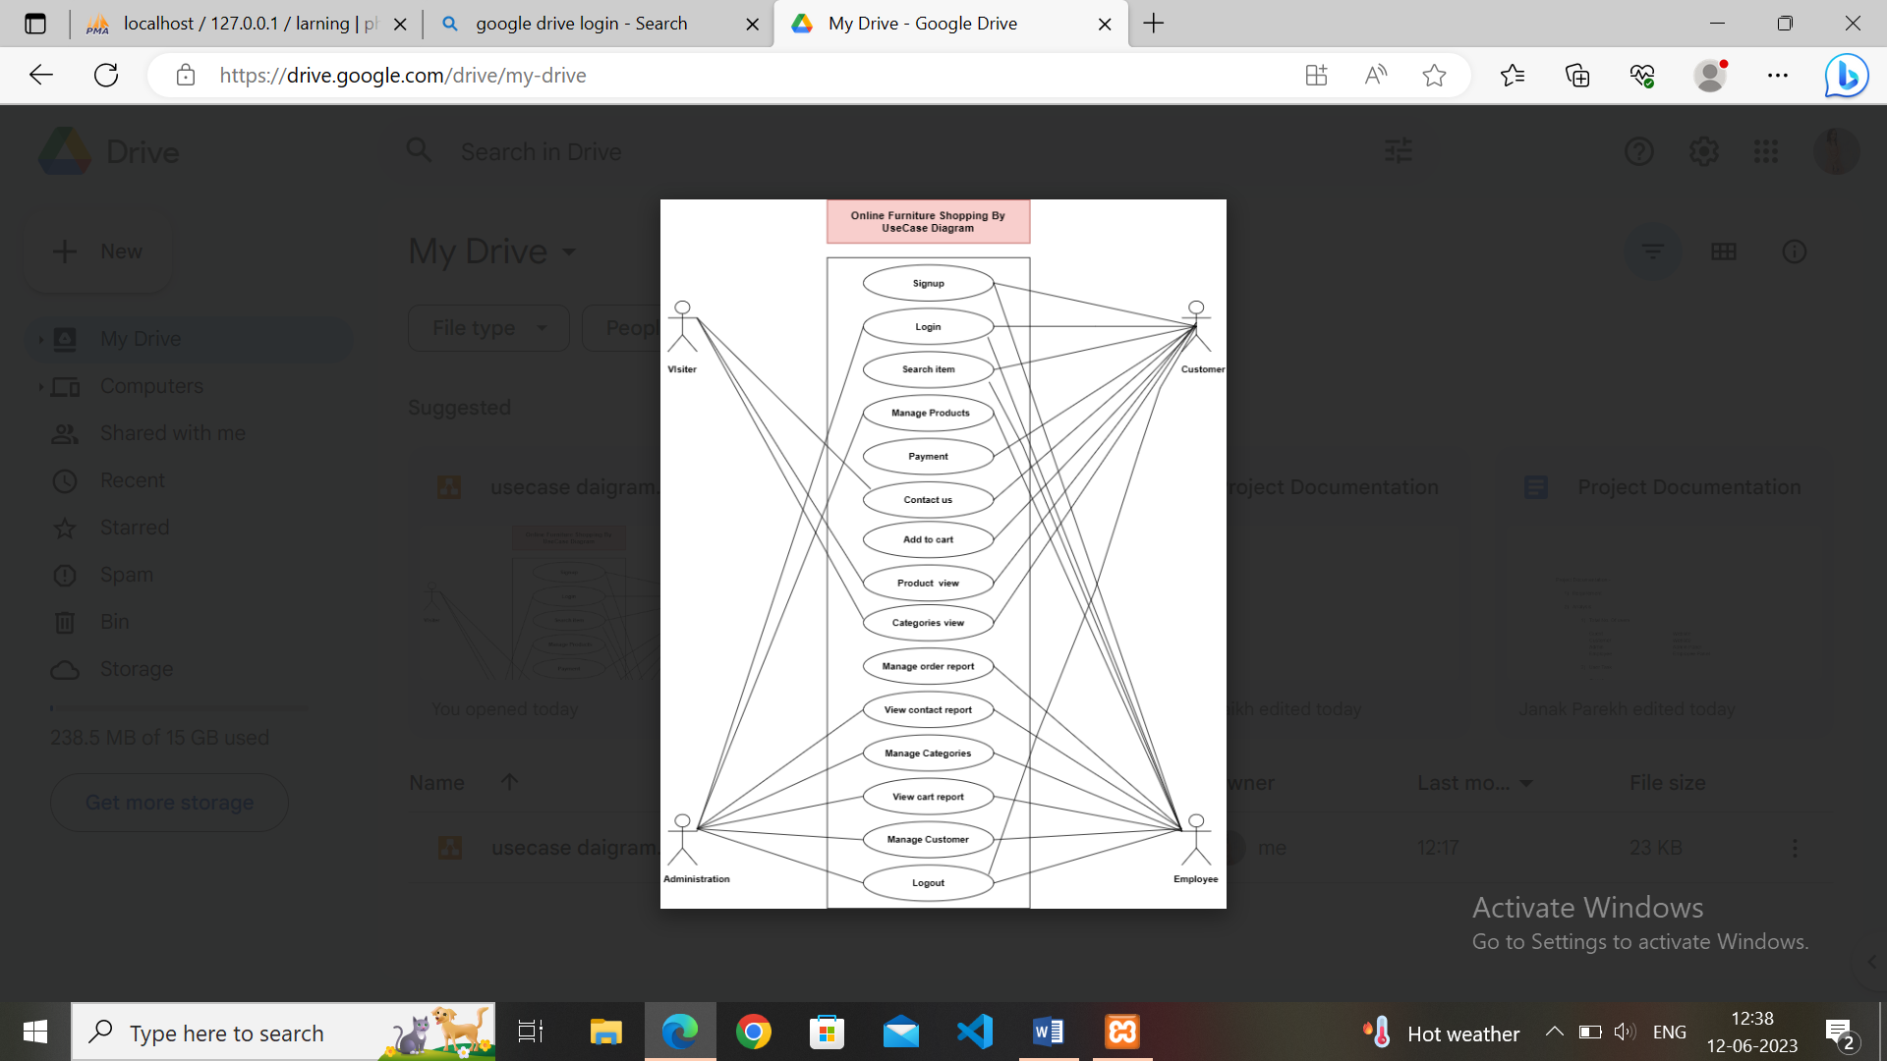

* **DFD {Data Flow Diagram}**
  1. **Level 0 / Context level Digram**

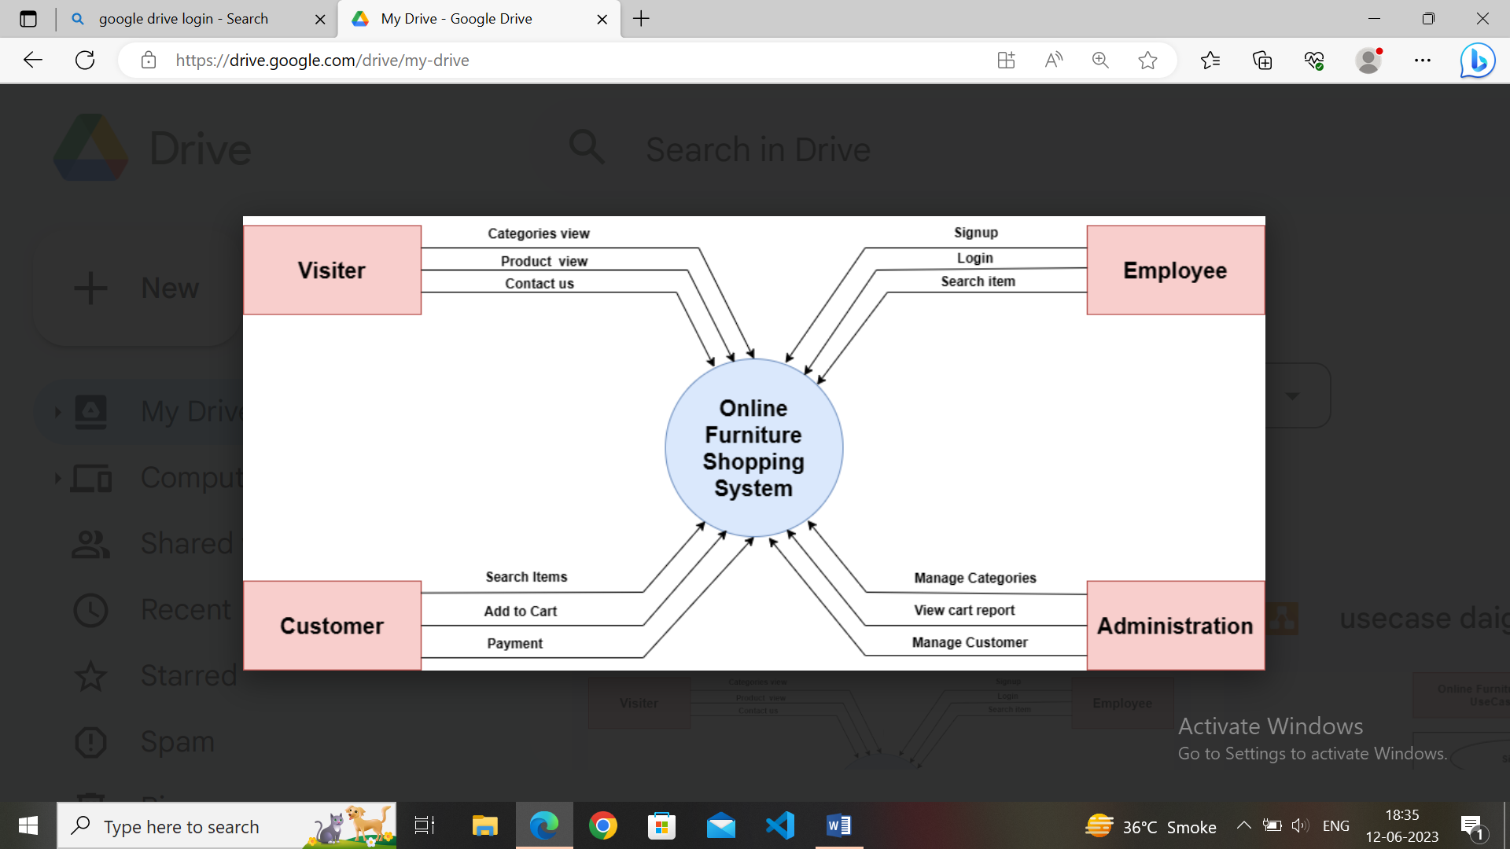

* **Level 1-DFD**

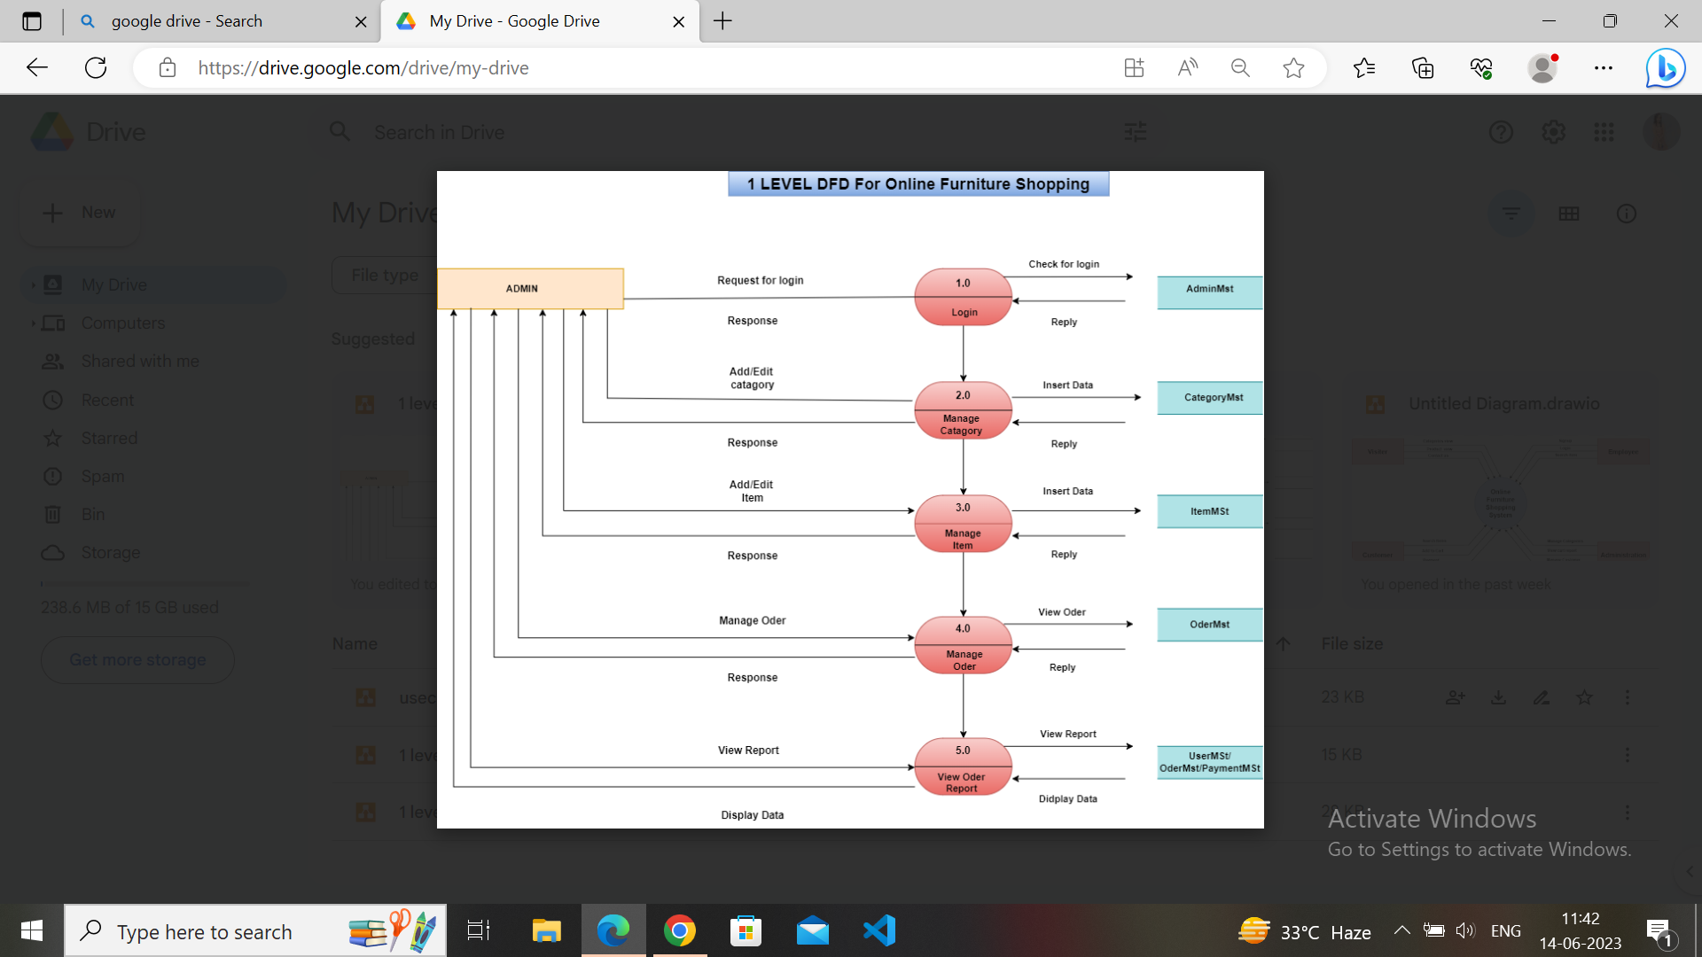

1. **Define Total Numbers of table list**

* 1. **Category_Table**
  2. **Product_Table**
  3. **Customer_Table**
  4. **Cart_Table**
  5. **Wishlist_Table**
  6. **Order_Table**
  7. **Payment_Table**
  8. **Contact_Table**
  9. **Admin_Table**
  10. **Employee_Table**

1. **Define each table of c**

**Category_Table**

**Id                              (Primary Key)**

**Category_name**

**Category_img**

**Created_at**

**Updated_at**

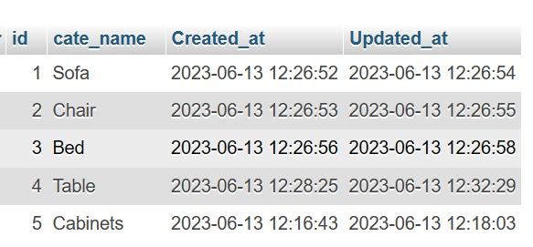

**Product_Table**

**Id                              (Primary Key)**

**Cate_id                    (Foreign Key)**

**Product_name**

**Discount_price**

**Main_price**

**Description**

**Product_img**

**Created_at**

**Updated_at**

**Customer_Table**

**Id                              (Primary Key)**

**Name**

**Username**

**Password**

**Address**

**Mobile**

**Gender**

**Pincode**

**Created_at**

**Updated_at**

**Cart_Table**

**Id                              (Primary Key)**

**Prod_id**

**Cust_id                     (Foreign Key)**

**Quantity**

**Cat_id(FK)**

**Total**

**Created_at**

**Updated_at**

**Wishlist_Table**

**Id                              (Primary Key)**

**Prod_id**

**Cust_id                     (Foreign Key)**

**Created_at**

**Updated_at**

**Order_Table**

**Order_id (Primary Key)**

**Cart_id (Foreign Key)**

**Created_at**

**Updated_at**

**Paymnt_Table**

**ID (Primary Key)**

**Order_id (ForeignKey)**

**Created_at**

**Updated_at**

**Contact_Table**

**ID (Primary Key)**

**Cus_id (Foreign Key)**

**Query (Foreign Key)**

**Created_at**

**Updated_at**

**Admin_Table**

**ID (Primary Key)**

**Email**

**Password**

**Cus_id (Foreign Key)**

**Cat_id (Foreign Key)**

**Prod_id (Foreign Key)**

**Cart_id (Foreign Key)**

**Order_id (Foreign Key)**

**Payment_id (Foreign Key)**

**Employee_id (Foreign Key)**

**Feedback_id (Foreign Key)**

**Contact_id (Foreign Key)**

**Craeted_at**

**Updated_at**

**Employee_Table**

**ID (Primary Key)**

**Emp_name**

**Password**

**Cus_id (Foreign Key)**

**Cat_id (Foreign Key)**

**Prod_id (Foreign Key)**

**Cart_id (Foreign Key)**

**Order_id (Foreign Key)**

**Payment_id (Foreign Key)**

**Feedback_id (Foreign Key)**

**Contact_id (Foreign Key)**

**Craeted_at**

**Updated_at**

1. **Create Data Dictionary**

* **Category Data Dictionary**

|  |  |  |
| --- | --- | --- |
| Field Name | Data Type | Field Size |
| ID(PK) | Int | 11 |
| Category_name | Varchar | 255 |
| Category_img | Varchar | 255 |
| Created_at | Datetime | - |
| Updated_at | Datetime | - |

* **Product data dictionary**

|  |  |  |
| --- | --- | --- |
| Field Name | Data Type | Field Size |
| ID(PK) | Int | 11 |
| Cat_id(FK) | Int | 11 |
| Prod_name | Varchar | 255 |
| Disc_price | Int | 11 |
| Main_price | Int | 11 |
| Description | Varchar | 255 |
| Prod_img | Varchar | 255 |
| Created_at | Datetime | - |
| Updated_at | Datetime | - |

* **Customer data dictionary**

|  |  |  |
| --- | --- | --- |
| Field Name | Data Type | Field Size |
| ID(PK) | Int | 11 |
| Name | Varchar | 255 |
| Username | Varchar | 255 |
| Password | Varchar | 255 |
| Email | Varchar | 255 |
| Mobile | Bigint | 11 |
| Gender | Varchar | 255 |
| Address | Varchar | 255 |
| Pincode | Bigint | 8 |
| Created_at | Datetime | - |
| Updated_at | Datetime | - |

* **Cart data dictionary**

|  |  |  |
| --- | --- | --- |
| Field Name | Data type | Field Size |
| ID(PK) | Int | 11 |
| Cust_id (FK) | Int | 11 |
| Prod_id(FK) | Int | 11 |
| Cat_id(FK) | Int | 11 |
| Qty | Big int | 11 |
| Total | Big int | 15 |
| Created_at | Datetime | - |
| Updated_at | Datetime | - |

* **Wishlist Data Dictionary**

|  |  |  |
| --- | --- | --- |
| Field Name | Data Type | Field Size |
| ID(PK) | Int | 11 |
| Cust_id(FK) | Int | 11 |
| Prod_id(FK) | Int | 11 |
| Created_at | Datetime | - |
| Updated_at | Datetime | - |

* **Order Data Dictionary**

|  |  |  |
| --- | --- | --- |
| Field Name | Data Type | Field Size |
| ID(PK) | Int | 11 |
| Cart_id(FK) | Int | 11 |
| Created_at | Datetime | - |
| Updated_at | Datetime | - |

* **Payment Data Dictionary**

|  |  |  |
| --- | --- | --- |
| Field Name | Data type | Field Size |
| ID(PK) | Int | 11 |
| Order_id(FK) | Int | 11 |
| Created_at | Datetime | - |
| Updated_at | Datetime | - |

* **Contact Data Dictionary**

|  |  |  |
| --- | --- | --- |
| Field Name | Data type | Field Size |
| ID(PK) | Int | 11 |
| Cus_id(FK) | Int | 11 |
| Query | Varchar | 255 |
| Created_at | Datetime | - |
| Updated_at | Datetime | - |

* **Admin data dictionary**

|  |  |  |
| --- | --- | --- |
| FieldName | Data type | Field Size |
| ID(PK) | Int | 11 |
| Email | Varchar | 255 |
| Password | Varchar | 8 |
| Cus_id(FK) | Int | 11 |
| Cat_id(FK) | Int | 11 |
| Pro_id(FK) | Int | 11 |
| Cart_id(FK) | Int | 11 |
| Order_id(FK) | Int | 11 |
| Payment_id(FK) | Int | 11 |
| Emp_id(FK) | Int | 11 |
| Feedback_id(FK) | Int | 11 |
| Contact_id(FK) | Int | 11 |
| Created_at | Datetime | - |
| Updated_at | Datetime | - |

* **Employee_data dictionary**

|  |  |  |
| --- | --- | --- |
| Field Name | Data type | Field Size |
| ID(PK) | Int | 11 |
| Emp_name | Varchar | 255 |
| Password | Varchar | 8 |
| Cus_id(FK) | Int | 11 |
| Cat_id(FK) | Int | 11 |
| Pod_id(FK) | Int | 11 |
| Cart_id(FK) | Int | 11 |
| Order_id(FK) | Int | 11 |
| Payment_id(FK) | Int | 11 |
| Feedback_id(FK) | Int | 11 |
| Contact_id(FK) | Int | 11 |
| Created_at | Datetime | - |
| Updated_at | Datetime | - |

**3) Designing /Theme integration**

**4) Implementation  / Coding**

**5) Testing / check website without error or bugs**

**6) Maintenance / guide / training / after service /**

**installation**

---------------------------------- ******************---------------------------------